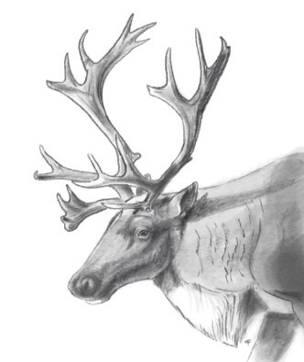

1:00 – 3:00 pm October 13, 2021

MLIB: Lisa Krebs, Brian Toth, Scott McNay
BC: Heather Wiebe (absent 1-2), Loni Arman, Ryan Bichon, Kathi Zimmerman, Darcy Peel
ECCC: Robin Steenwig (Absent: Jaspal Aulakh, Renée Lapointe)

Action Review
Apr. 14-May 12 | BC to respond to IMA, funding work plan, G2G (not being the mechanism BC wants for agreement) and Sec 11 – 7.2 MOU.  - Bryan will provide letter prior to May 26th  - - Look at March 26 work plan funding submission for components for the 7.2 MOU  - June 23rd – Letter being completed, there will be a formal response from the Minister to address Chief Chingee’ s June 15th letter, email from ED Laroche responding to Chief Chingee’s concern in the June 15th letter regarding MLIB topic on PA agenda.  - Update – on hold | Bryan W
June 23 | BC to draft a MOU (term sheet) ID headers, parameters, roles, and responsibilities – other provisions to be worked on together  - Will be ready for discussion for July 21st meeting – Did not occur. – on hold until Canada can participate | BC (Bryan W)
June 23 | MLIB to have an internal discussion on restoration – ID priority herds, MLIB’s capacity, how to be involved in work (writing prescriptions, ground truthing, actual on the ground work) | Lisa/Brian
Sept 15 | Funding 50,000 Stob 80 (Shared cost arrangement) in draft will have agreement in coming days.  MLIB (Lisa) to provide brief general overview of where money might be used (ethno/community meeting/etc.)  Linking to Scott’s work, linking to Parsnip LUP  Updates Oct 13:  Lisa will provide an overview to Loni  Restoration -still exploring the restoration –– Scott is working on it and on a call tomorrow with FSJ caribou to discuss road in question  ECCC contribution agreement is being negotiated – Lisa and Agathe in conversations | Loni/Lisa

Parsnip Analysis: Brian/Scott/Sofia
- Full presentation to be available once updated (below are screen shots)
- Status of caribou and their habitat within Burnt Pine, North Hart, Kennedy siding and Scott West
- Phase 1 collect historic/ up to date info
- 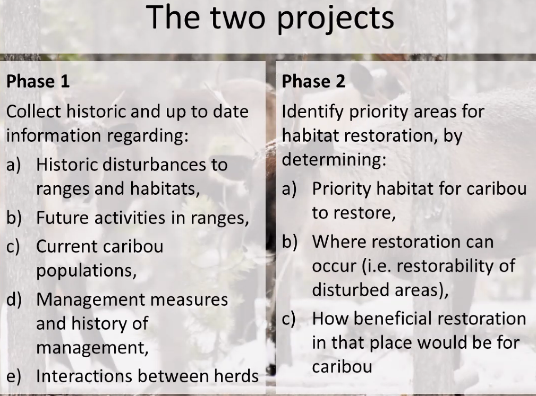
- 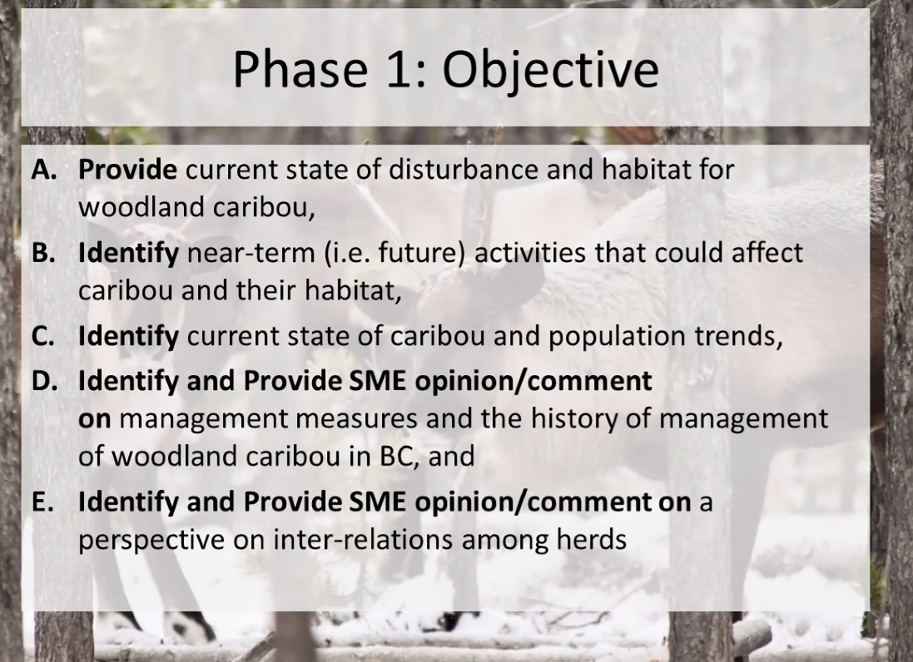

- Data collected through BC data, historic disturbance and forestry quarterly summaries for historic and near term.
- 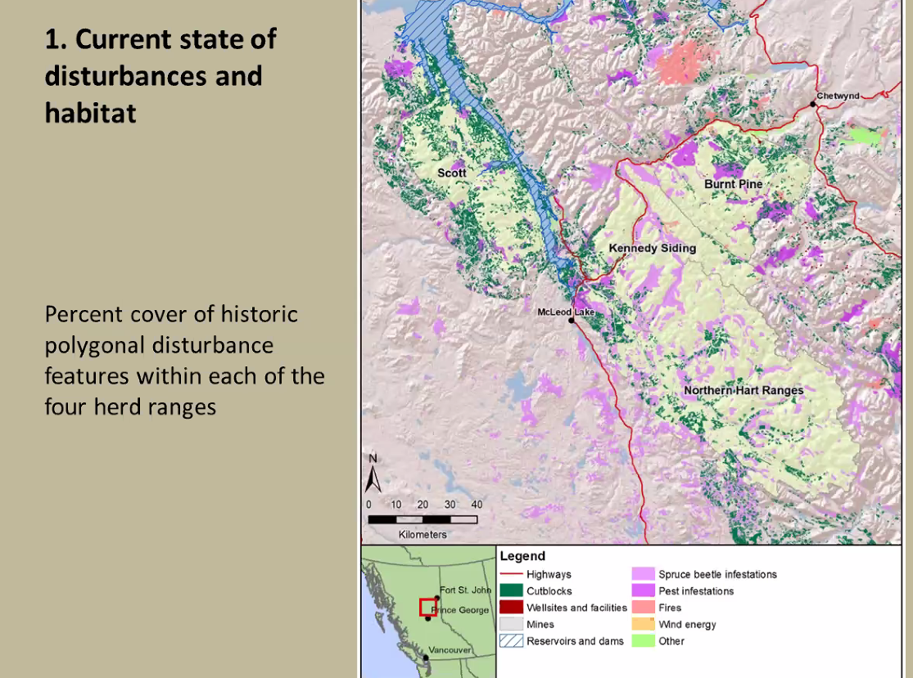
- KS has highest, then Scott west, burnt pine, harts (polygonal disturbance)
- Linear most in burnt pine
- Percent cover of core cover in harts then KS, SW then BP
- 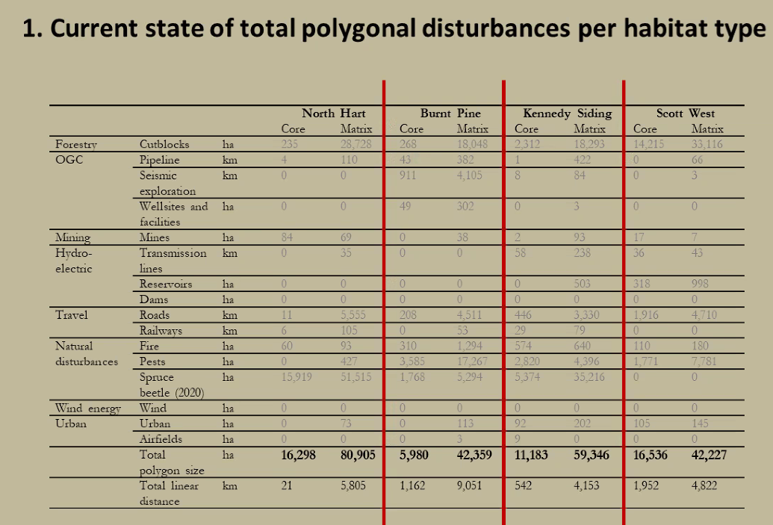
- Cut Blocks and Spruce Beetle have highest disturbance followed by roads
- Comparison is used by ECCC 65%, anthropogenic disturbance 500 m buffer
- Near term planned activities – Scott West most, Burnt Pine and Harts equal then Kennedy Siding
- Oil & Gas most in Scott West and Harts
- 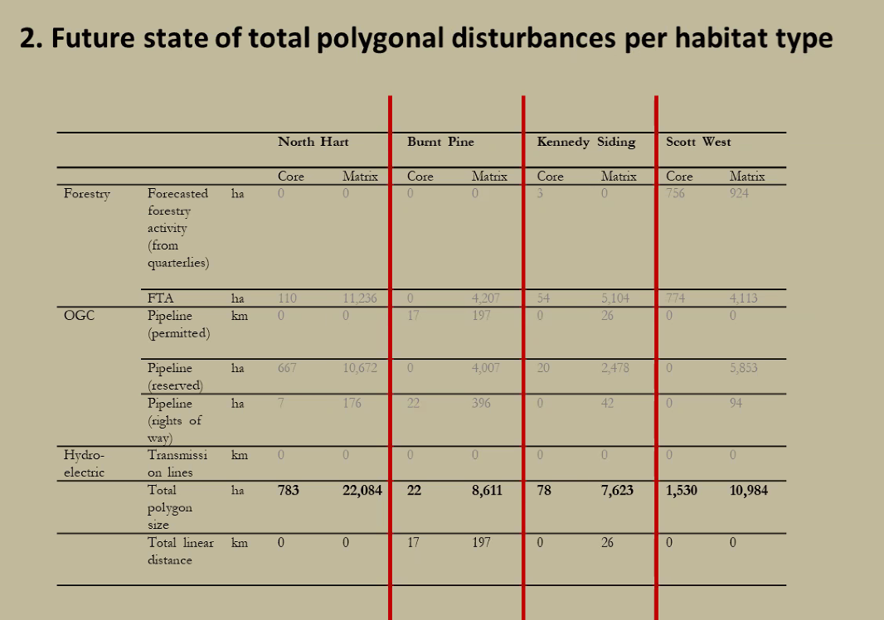
- Movement between herds
  - Scott – these are radio collared animals so biased on # of collars
  - From talking with Dale largest amount of overlap is Kennedy Siding and Burnt Pine – overlap significant, a bit of movement between Kennedy Siding and Klinse-za would rank that second
  - Graph is only with collared females
- Should be looking at adjacent herds to understand relationships (ex Quintette)
- Will be collaring males this year
- Inter herd relationships might indicate a population status but temporal aspect is missing
- What is the direction with Burnt pine? There hasn’t been a decision at this point. Federal unit of conservation is the Local Population Unit. Some progress at LPU scale.
- Is there a discussion about sustainability viability or is that part of herd planning?
  - This is what BC is working on – gaining understanding of existence disturbance. BC has completed a disturbance analysis BC has looked at HER, HEWS, LEW, LES, Matrix
  - We look at prioritizing at where we do recovery actions to look at where our efforts can make a difference – Southern Mountain Caribou, focussing on existing herds that are more viable for sustainability
  - Kathi will share BC’s disturbance – action – completed Loni sent
- Robin would like to know if there is more disturbance in the BC data then what is in ECCC data
- ECCC has annualized version of data set that is available
- Carry forward conversation for next meeting
  - Revisit through email

ESI/Wolverine Herd: Keri Dresen, Justin Calof
(Participants: MLIB: Maya BC: Keri Dresen, Kevin Hoekstra, Justin Calof, Ken Sehn, James Jacklin, Tara Bogh, Leanne Elliot, Norm Bilodeau)
- 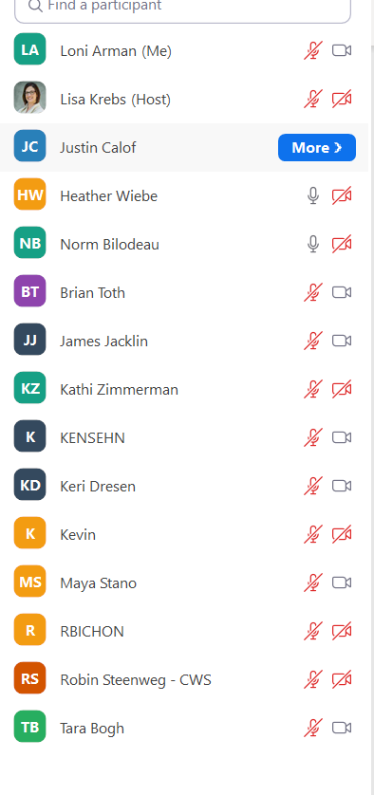
- Set out context and start discussion
- Caribou discussions occurred as a result of the Partnership Agreement
- We are looking at technical projects as we gain understanding of caribou in the territory.
- And how it ties to LUP
  - How we are managing caribou habitat and how it relates to recovery
- How does MLIB fit in?
- G2G been focussing on moose, previously identified through collaborative wildlife management, also governance rights
- Justin to add to context – starting discussion on process design
- In addition to stewardship context (Cumulative Effects issue) separate and included is the economic piece ex forest tenure, community resilience
- Timber supply challenging
- Interest we share but lots of challenges ahead of us
- Third piece of context – process – need to be mindful of how to address MLIB’s interests
  - Reconciliation – relationship with CSFN – situated in reconciliation relationship with CSFN, context today ties to reconciliation and addressing rights and title
  - Parallel with TKDN operating similar to reconciliation piece
  - “reconciliation process”
  - Need to be careful with process design that navigates these things and addresses MLIB’s interests
- Caribou recovery – Kennedy Siding and Hart ranges in MLIB territory working on at the Tripartite Table
  - Wolverine herd – all other layers of context that need to be considered in how MLIB’s interests are synergistic on how we manage – multi value considerations
  - Brian – scope LUP, caribou recovery, Caribou LUO’s
    - Thought of Parsnip of different as it doesn’t have same overlap
    - Distinction is yet to be made – looking for clear path
    - Maya – parsnip like a pilot to launch and cover MLIB territory
    - Lisa – Parsnip has opportunity – caribou LUO’s but also look at some level of management, curious to see what they are doing in RMP with caribou
  - Caribou LUO is anchor in context of land use
  - How does MLIB incrementally work towards greater stewardship objectives, grow Parsnip then throw it out
- Will take it back and bring some clear proposals back – Justin
- Two discreet areas in MLIB territory may need to be coordinated
- What’s going on in Wolverine and how it feeds into RMP
  - RMP is a concept that Brian coined the phrase term to describe approach to LUP that CSFN’s and TKDN want to move forward
  - BC perspective all govs have economic, stewardship and Land Use objectives
  - Haven’t initiated it yet
  - Early days BC brought interest forward to integrate caribou into broader Multi value context
  - Think Wolverine herd will be part of this process
  - Trying to come to agreement on what is the current state of the herd
  - How current state feeds into broader process
  - Transparency is critical
  - Start technical work on the current state
  - Design process on integration – which technical unit are we using, standardize thresholds
  - How have you worked with COLT to bring in SARA commitments (technical piece)?
    - They have not yet – those are discussions before us
  - What has been discussed for governance in terms of RMP?
    - Still at ground floor, what is the relationship across 3 govs (TKD, BC, CSFN) how will decisions be made with goal of consensus
    - BC has broader accountabilities to other First Nations and stakeholders (Forestry/Mining/etc.) still have not discussed how these are managed, and how accountabilities are discharged
    - BT - Starting point a presentation on RMP from Justin and Brian
    - How does the process cut across the different nations and caribou?
    - Foundation for management change is important and how those technical pieces are used and how it is imputed in other processes (DMK TSR)
    - Interest from MLIB in economic and stewardship (caribou and broader F&W G2G)
    - MLIB interest positioned at different tables
  - How to integrate? In Wolverine context we need to have that discussion, there could be more value in an integrated approach.
  - Need to recognize the two tables and the interest for a more integrated approach, here to brainstorm best approach to move forward with
  - Use Parsnip as starter
- Heather – so many overlaps with multiple values – at caribou table provides opportunity for ECCC so a bit different
  - Lisa – we can’t forget the 3 levels of gov at caribou table not suggesting dissolving tables
- Next steps on Process Design
  - Brian and Justin discussing interests around BC and CSFN
  - Should share that with MLIB
  - Challenge two discreet areas in MLIB how to manage so they aren’t divided
  - Need to get into process design
  - Create transparency
  - How do 4 gov talk
  - How do we manage process with respect to 2 parts?
  - Timeline over next 2-3 weeks

